**MINI PROJECT**

**(2024-25)**

**Campus Network Design Using**

**Cisco Packet Tracer**

**PROJECT REPORT**



**University of Engineering & Technology**

# Submitted By:-

Muhammad Aarish Ayaz (21MDBCS107)

Muhammad Haroon (21MDBCS109)

Muhammad Uzair (21MDBCS111)

## *Supervised By: -*

## Dr. shams ur Rahman

Professor

**Department of Computer Science**

# 

# ABSTRACT

Computer networks have a significant impact on the working of an organization. Universities depend on the proper functioning and analysis of their networks for education, administration, communication, e-library, automation, etc. An efficient network is essential to facilitate the systematic and cost-efficient transfer of information in an organization in the form of messages, files, and resources. The project provides insights into various concepts such as topology design, IP address configuration, and how to send information in the form of packets to the wireless networks of different areas of a University.

The aim of this project is to design the topology of the university network using the software Cisco Packet Tracer with the implementation of wireless networking systems. This university network consists of the following devices:

1. Router (1941)
2. Switches (2960-24TT)
3. Email server
4. DNS server
5. WEB server (HTTP)
6. Wireless Device (Access Point)
7. PCs
8. Laptops
9. Smartphones

The design includes the following parts of the University:

• **Hostel Blocks**: Girls Block and Boys Block

## • Academic Blocks: AB1 and AB2

## • Dome Building and Library

• **IT Consulting**

# INTRODUCTION

## ● Motivation

The word “digital” is very significant in today’s world, with an increase in the development of technology the entire world is moving towards the digital era. The educational institution plays an important role in this digitalization, hence the campus should adapt to digital means of networking as well and become a “digital campus”. Going wireless plays an important role in this digitalization. The wireless network makes the connection easy with a reduction in the use of wires or cables. A wired connection makes it difficult to keep track of all the devices and to manage the cable connection, which is not only chaotic but also challenging to handle.

Campus networking via wireless connection becomes an important part of campus life and provides the main way for teachers and students to access educational resources, which gives an important platform to exchange information. As laptops and intelligent terminals are widely used, demand for access to information anytime and anywhere has become more and more urgent, but traditional cable networks cannot meet this requirement. Then wireless network construction becomes necessary and essential. The wireless network is one of the important components of a digital campus and wisdom campus. It provides an efficient way to explore the internet with a mobile terminal for teachers and students regardless of cables and places.

This is an important mark of the modern campus as a supplement of a cable network. With the development of network and communication technology, cable networks on a university campus bring much convenience for teaching and research work. But for mobility and flexibility, it has obvious shortcomings. A wireless network can overcome these drawbacks and has been applied to the university campus.

## ● Project Statement

In this mini-project, we defined a simulation of campus networks based on wireless networking. The network is divided into two sets: one for the campus area and the other for the hostel area.

The major aim of this project is to show the wireless connectivity that is used in universities to make the network efficient and mobile at the same time. Mobility is the major concentration of this project. In order to provide equal functionality to all the users (college staff and students), we have added DNS, Email, and HTTP servers for the maximum utilization of resources.

Hence the campus network provides different services such as connecting the user to the internet, data sharing among users (students, teachers, and different university members), accessing different web services for different functionalities, so it needs wireless networking for smooth processing.

# WORK DONE

In order to make our project understandable, we have divided the content into steps. They are as follows:

## 1. Software and hardware requirements

Before heading towards the implementation we need to make sure of the following requirements.

* A proper workstation (any mid-high range laptop will suffice).
* Packet Tracer by Cisco ● 8 GB RAM.
* Any 10,000+ Average CPU Mark scored processor.
* 16 GB of dedicated hard disk space.
* USB 3.0+ port.

## 2. Network Requirements

University outline is considered for this wireless university network.

The network is divided into 2 areas :

## 1. Campus Area

The Campus area is further divided into various accessing points like Dome building, Library, Academic Blocks (AB1 and AB2), Server Center, and IT consulting.

## 2. Hostel Area

The Hostel area is further divided into Boys blocks and Girls blocks respectively.

### 3. Layout

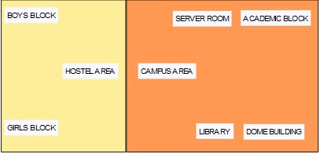

Figure – Basic Layout of our wireless access points in University

Devices Used In The Network

|  |  |
| --- | --- |
| Devices | Quantity |
| 1) Router (1941) | 3 |
| 2) Switches (2960-24TT) | 3 |
| 3) EMAIL server | 1 |
| 4) DNS server | 1 |
| 5) WEB server (HTTP) | 1 |
| 6) Wireless Device (Access Point) | 7 |
| 7) PCs | 12 |
| 8) Laptops | 10 |
| 9) Smartphones | 2 |

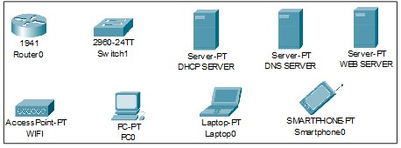

Figure 3: Devices used in the network

### 4. Implementation and Flow Diagram

* To design the wireless network of the university we initially started by placing the core devices into the frame as mentioned in the layout.

* Firstly, we placed the **main router** at the center of the university outline, which was further connected to the **server switch** using the gigabit ethernet port with copper straight-through cable and sub routers (**campus router and hostel router**) using the serial port with serial DCE cable at the hostel area and campus area respectively.

* The server switch was further connected to the **EMAIL, DNS, and WEB** servers respectively.

* Campus router was connected to the campus switch which was further connected with wireless access points of the academic block (**AB1 and AB2**), **dome building**, **library,** and **IT consulting.**

* The wireless access points were then connected to computing devices (PCs, laptops, and smartphones).

* Similarly, the hostel router was connected to the hostel switch which was further connected with the wireless access point of boys block and girls block.

* The wireless access points were then connected to the computing devices (PCs, laptops, and smartphones), every area has a dedicated access point which can only be connected with the help of a password.

* All these connections are made through Ethernet ports (gigabit Ethernet and fast Ethernet) using copper straight-through cables.

### 5. Configuring IP Addresses

We have attached the screenshots of all the IP configuration below:

* Main Router configuration

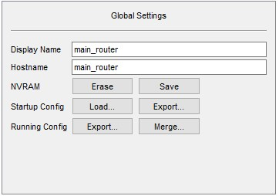

GigabitEthernet0/1

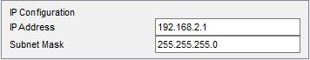

Serial0/1/0

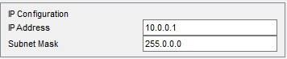

Serial0/1/1

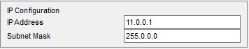

RIP

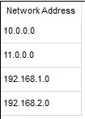

* **DNS SERVER**

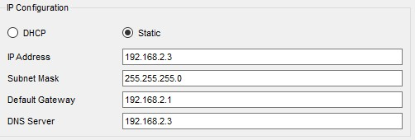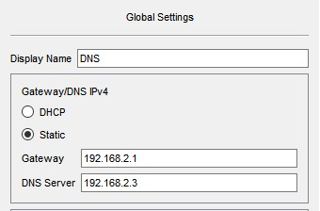

* **WEB SERVER**

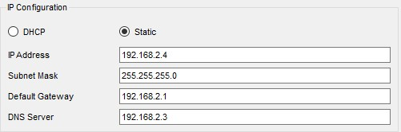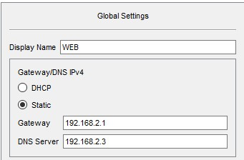

* **EMAIL SERVER**

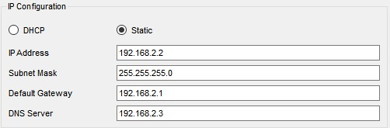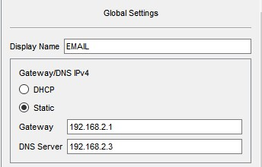

* **UNIVERSITY ROUTER**

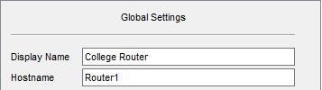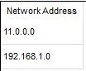

GigabitEthernet0/0

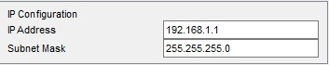

Serial0/1/0

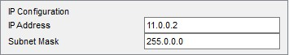

### ● ACADEMIC BLOCK 1

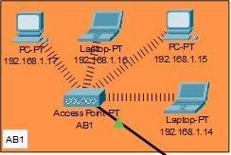

IP Address are as follows

192.168.1.14- Laptop

192.168.1.15- PC

192.168.1.16- Laptop

192.168.1.17- PC

Subnet Mask- 255.255.255.0

Default Gateway- 192.168.1.1

DNS Server- 192.168.2.3

### ● ACADEMIC BLOCK 2

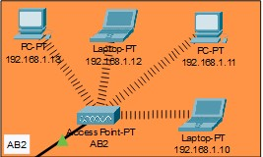

IP Address are as follows

192.168.1.10- Laptop 192.168.1.11- PC

192.168.1.12- Laptop

192.168.1.13- PC

Subnet Mask- 255.255.255.0

Default Gateway- 192.168.1.1

DNS Server- 192.168.2.3

### ● DOME BUILDING

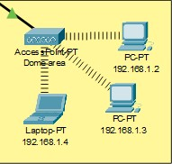

IP Addresses are as follows

192.168.1.2- PC

192.168.1.3- PC

192.168.1.4- Laptop

Subnet Mask- 255.255.255.0

Default Gateway- 192.168.1.1

DNS Server- 192.168.2.3

### ● LIBRARY

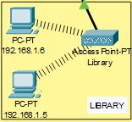

IP Addresses are as follows

192.168.1.5- PC

192.168.1.6- PC

Subnet Mask- 255.255.255.0

Default Gateway- 192.168.1.1

DNS Server- 192.168.2.3

### ● IT Consulting

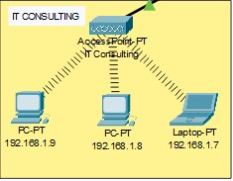

IP Addresses are as follows

192.168.1.7- Laptop

192.168.1.8- PC

192.168.1.9- PC

Subnet Mask- 255.255.255.0

Default Gateway- 192.168.1.1

DNS Server- 192.168.2.3

### ● HOSTEL ROUTER

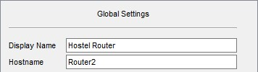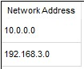

GigabitEthernet0/0

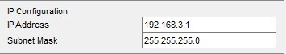

Serial0/1/0

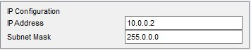

### ● Boys Block

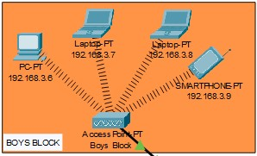

IP Addresses are as follows

192.168.3.6- PC

192.168.3.7-Laptop

192.168.3.8- PC

192.168.3.9- Smartphone

Subnet Mask- 255.255.255.0

Default Gateway- 192.168.3.1

DNS Server- 192.168.2.3

### ● Girls Block

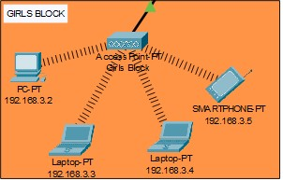

IP Addresses are as follows

192.168.3.2- PC

192.168.3.3-Laptop

192.168.3.4- PC

192.168.3.5- Smartphone

Subnet Mask- 255.255.255.0

Default Gateway- 192.168.3.1

DNS Server- 192.168.2.3

### ● WIRELESS ACCESS POINT

|  |  |
| --- | --- |
| SSID | Password |
| 1)UET_dome | 1234567890 |
| 2) UET_library | 1234567890 |
| 3) UET_ITC | 1234567890 |
| 4) UET_AB1 | 1234567890 |
| 5) UET_AB2 | 1234567890 |
| 6) UET_boys | 1234567890 |
| 7) UET_girls | 1234567890 |

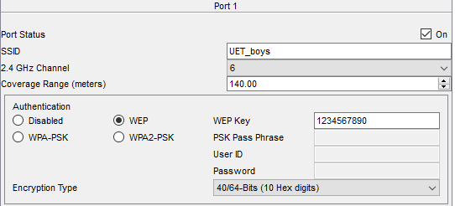

**Connectivity of wireless**

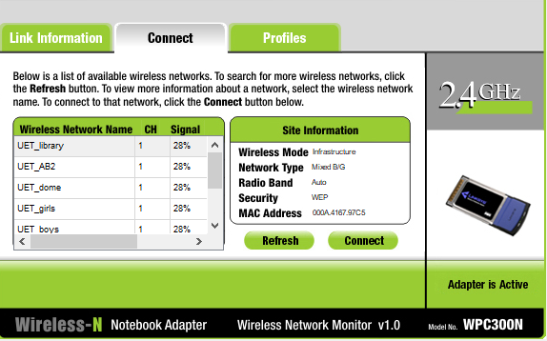

**Connectivity of wireless network on computing devices**

# 

# RESULT & DISCUSSION

Finally, we have combined all the steps and implemented the desired wireless network for University. We have the complete network providing various facilities to the teaching staff, non-teaching staff, and students.

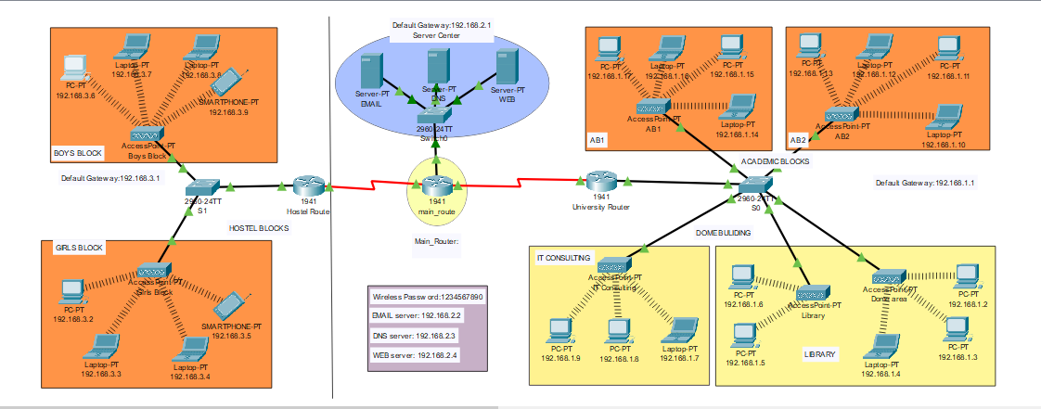

The complete diagram of the University Area Network Scenario created in Packet

Tracer environment

## ● Final Simulation

In Simulation Mode, you can watch your network run at a slower pace, observing the paths that packets take and inspecting them in detail. The proposed architecture, when simulated on Cisco Packet Tracer, produced results which are demonstrated as follows:

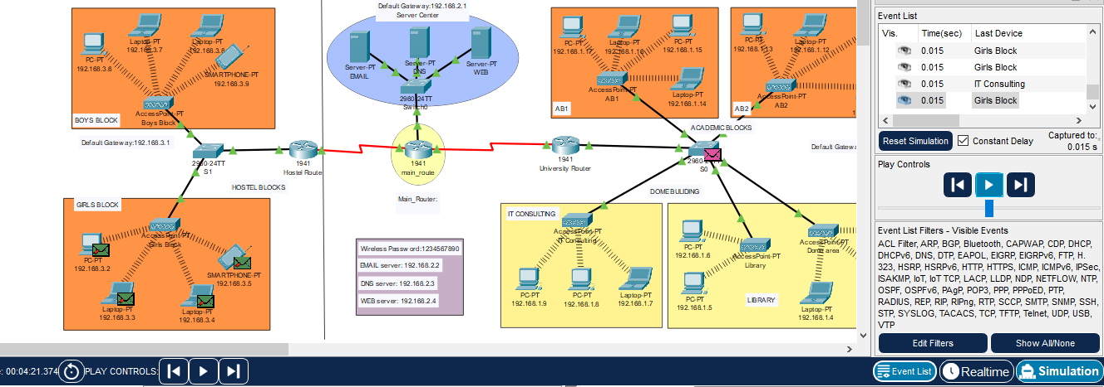

Final simulation for the network system to check all the connections

● **Ping Test:** Network connectivity and communication can be tested using the ping command, followed by the domain name or the IP address of the device (equipment) whose connectivity one wishes to verify.

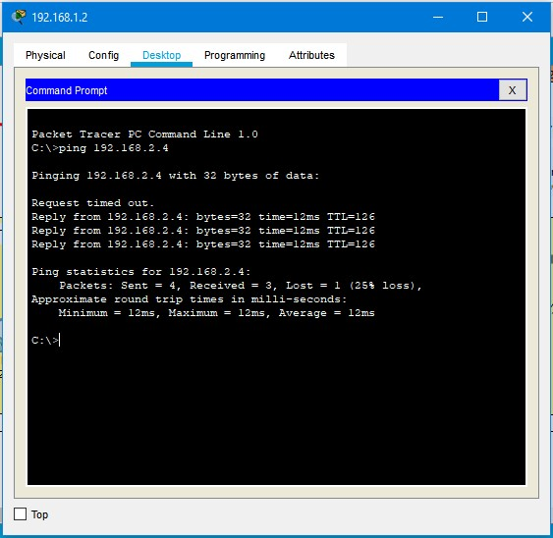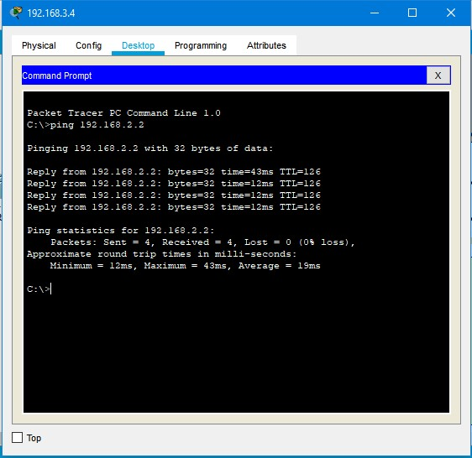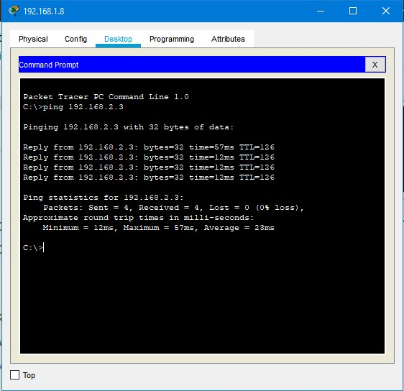

**SCREENSHOTS –**

## Logical View

Screenshot

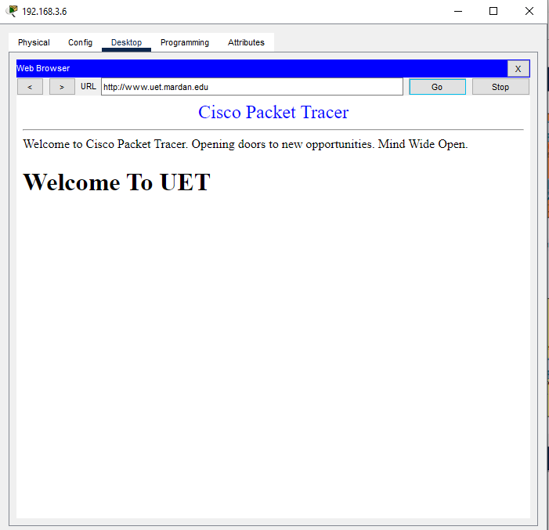

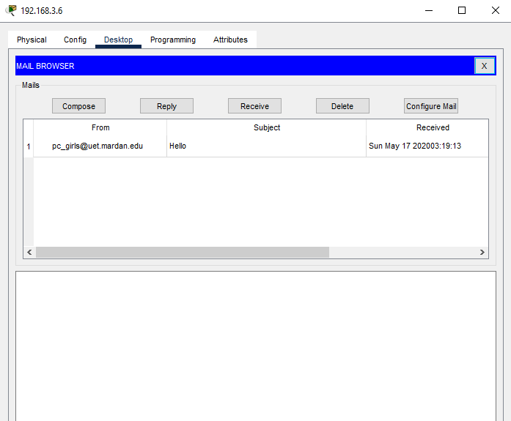

# 

# CONCLUSION AND FUTURE WORK

## ● Conclusion

We started our discussion with the word “digitalization” and in order to achieve it, we aimed to start with an educational institute, and finally, we designed a network for a University, which is wireless. As we mentioned, mobility and efficiency are the key aspects of wireless networks, which were our main goal, and hence, we decided to shift to a wireless network instead of a wired one, making our network clean and less chaotic.

In this project, we designed a University Network using Cisco Packet Tracer that uses a networking topology implemented using servers, routers, switches, and end devices in a multiple area networks. We have covered all the necessary features that are required for a network to function properly. We have included a DNS server and a web server for establishing a smooth communication system between different areas of our network and specifically for the communication between students and teachers. We have included an email server to facilitate intra university communication through emails within the domain.